|  |  |
| --- | --- |
| C:\Users\arielsc\Documents\Office TPM team\LOGOS\AppsLogo_rgb_Excel_Grn348.png | Excel 2013 |
|  | Demo Track |
|  | PMM: Ari Schorr |

Demo setup

Recommended sample content is available in the **Internet Sales**, **Statement 2012-11**, and **Statement 2012-10** workbooks. Save the [folder containing these demo docs](http://infopedia/docstore/pages/KCDoc.aspx?DocId=193041) (including the **Spreadsheet Control DemoFiles**) to your local machine. Users must have the ***Office Professional Plus 2013*** Suite installed in order to use the Spreadsheet Inquire, Spreadsheet Compare, PowerPivot (not shown here), and Power View features.

Make sure that all necessary Add-Ins are enabled by doing the following steps:

1. Open the **Internet Sales** workbook and click FILE go to the Backstage.
2. Click Options/Add-Ins/COM Add-ins in the “Manage:” drop down menu. Click “Go…”

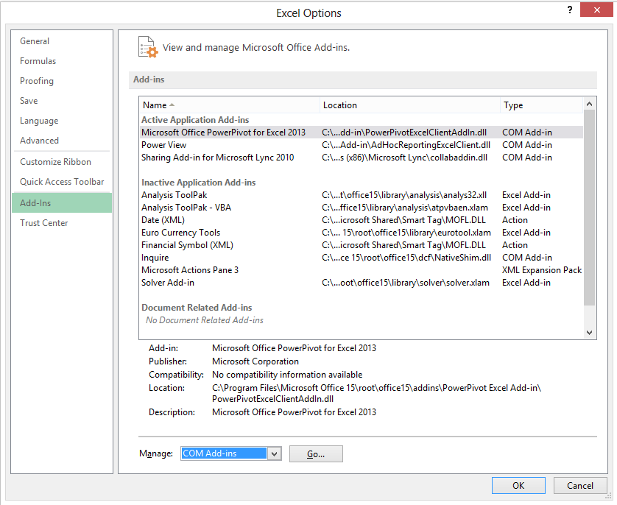

1. Enable Inquire, PowerPivot, and Power View add-ins by checking the boxes next to each. Click “OK”.

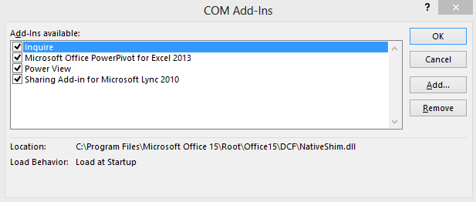

**NOTE:** You may have to repeat this process when you open each of the workbooks.

Demo

| **Talk Track** | **Click through** |
| --- | --- |
| Excel 2013 gives you intuitive ways to **explore** your data. In one click, **discover** new ways to **visualize** your data, and see your information in new depths. Let’s start by exploring some of the new insight discovery features. |  |
| It is common for users of Excel to want to reformat and rearrange data in different columns of a worksheet. For example, this could be separating names or addresses. This used to require complicated delimiting cell formulas or macros. With the new **Flash Fill** feature, watch Excel learn and recognize your pattern and auto-complete the remaining data. | Open the **Internet Sales** workbook. Click on the ‘Customer’ worksheet. Click in cell I2 under the ‘Country’ column. |
| Here we want to just take out the Country from the Location in column H. We type Australia to establish that this is what we want and then begin typing in the next row. Excel recognizes the pattern and flash fills the rest of the column for us. We can also do the same with City. This works not only with taking out text from a column but also for combining text found in two columns into one, such as first and last names into full name. | Type ‘Australia’ and press Enter. Start typing ‘United States’ and watch Flash Fill show the rest of the column values. Press Enter again to fill the column. Show with a new ‘City’ column in J if you think audience requires confirmation of the feature’s power. |
| Getting started with Pivot tables that allow you to get different views of your related data has always been difficult for customers. Now we have added **Recommended Pivot Tables** tohelp you find the best summary for your data and create a Pivot Table from any existing table. | Click on the ‘Sales’ worksheet and select the entire table (Ctrl+Shift+🡪) and then Ctrl+Shift+↓) |
| Excel suggests options for how to summarize your data into a pivot table. See a quick peek of your data in tables that use different pivots, and pick the one that lets the insights flow. | Click on the ‘Insert’ tab in the ribbon and ‘Recommended Pivot Tables’. |
| In this case, the best one for summarizing our data is the first recommendation, ‘Sum of TotalProductCost by Quarter’. A new worksheet is created with the new Pivot Table that we can begin drilling into to discover more insights. | Click on the ‘Sum of TotalProductCost by Quarter’. |
| Now that we have Pivot Table, we want to allow you to add the rest of the workbook tables’ fields to the Pivot Table. This will make it possible for you to drill up and down within all the related data in the workbook. | Within the Pivot Table you just added, click ‘More Tables…’. Click OK in the pop-up window. |
| We can use the **Quick Explore** feature to explore different cuts and views of your data in a click, and discover new insights hidden in your data. In a click, conduct a cross-tab analysis of large datasets and get a 360-degree view of what your data can show you. In this case, we want to see what products make up total product costs within Q3 of 2008. | Click cell B4, which shows the Sum of TotalProductCost for 2008/Q3. A magnifying glass symbol will appear, click it, then select ‘Products’ and ‘Drill To Product’ in the Explore view. |
| You can see that Bikes make up all of the costs from Q3 for 2008. Quick Explore can also be used with PivotCharts, whether they are linked to Pivot Tables or independent. |  |
| Financial statements, like this one here, are often the most mission critical spreadsheets in a company but are also sometimes exposed to potential unwanted errors when employees have access to them. With **Spreadsheet Inquire,** take control, help mitigate risk, and improve compliance by diagnosing your mission critical workbooks for errors, inconsistencies**,** hidden information, and other important aspects**.** | Open **Statement 2012-11.xlsm** and the “P&L Statement” worksheet.  Click on the INQUIRE tab on the top and then click ‘Workbook Analysis’. |
| Drive end-user productivity with automated reporting features that pinpoint and document spreadsheet design and function. Inquire includes valuable tools like workbook analysis, relationship diagrams, and Spreadsheet Compare. With workbook analysis, we can find formulas with errors quickly. Documentation of this analysis is available and can be submitted with a financial statement to validate credibility by simply clicking the ‘Excel Export’ button | Expand Formulas in the Items list by clicking the +, click “With errors”, and double-click on one of the formulas in the Results box so it takes your cursor to the cell in the workbook. |
| Inquire also allows you to discover data dependenciesat the workbook, worksheet, and cell level. First, we will see how you can identify workbook links to other workbooks, databases, or other data sources. Notice that it shows broken links (marked by an X) and out-of-date data.  The data goes from upstream (right) to downstream (left) and if an upstream file has a more recent Modified date than a downstream file, then the downstream file could have out-of-date information and it needs to be opened to get the most recent data into it. Workbook locations, modification dates, and warnings can be seen by hovering over the icon. | **SETUP REQUIRED BEFOREHAND REQUIRED (for best results):**  Make sure the entire **Excel 2013 Demo Docs** folder is saved to your local machine. Click on the DATA tab and then “Edit Links”. Select each of the files in the pop-up, click “Change Source”, and select the file with the same name within the **Spreadsheet Controls DemoFiles** folder on your machine. If you have done this correctly, all files should say “OK” rather than “Unknown” under “Status” in the “Edit Links” pop-up menu.  Click on Workbook Relationship on the INQUIRE tab to create a diagram of workbook links (NOTE: This may take a few minutes to generate and will remain blank until it does).  Hover over a few of the files with broken links to illustrate the details pop-up. |
| We can also discover dependencies at the worksheet level within the current workbook. You can see that it shows *all* sheets, even if they’re hidden or very hidden. | Click on ‘Worksheet Relationship’ to create diagram of relationships between worksheets in the workbook. Mouse over what appears to be 2 sheets with the same name (ExchRates) and one is “Very Hidden”. |
| Lastly, we can even discover dependencies at the cell level within the current workbook. This could be used to trace the origin of data or perhaps find the source of an error in a formula/cell reference. | Select cell B23 and then click the Cell Relationship Diagram using default settings. |
| Another one of the features available within Spreadsheet Inquire, as well as a separate application, is **Spreadsheet Compare**.Compare multiple versions of a workbook side-by-side to quickly gain visibility of important changes down to the cell level, including changes to workbook structure, formulas, cell values, VBA code, cell format, and more. Rest easy knowing during an audit, you have an audit trail of the changes in the spreadsheet. As part of the review or approval process for a critical file, like a monthly financial statement in this case, there is usually a need to compare the current workbook to a prior version. We want to make sure there are no formula changes, inserted or deleted rows, deleted columns, data entry, or VBA code (macro) changes. | Click “Compare Files” to run Spreadsheet Compare. Choose 2 versions of a file, **Statement 2012-11** and **Statement 2012-10**. Click “Compare”. |
| A side-by-side comparison launches in a new “Spreadsheet Compare” window. Take a look at the intuitive layout of Spreadsheet Compare, with the different change types shown in the bottom left corner that can be used to filter all the views (comparison, change list, and change chart) by checking/unchecking each. | Click the “PL Statement” tab in either of the files to pull up a color-coded comparison of the spreadsheet in both workbooks. |
| Notice how by checking only “Structural” changes, you can see how there were rows inserted or deleted. Also notice how the formula below the row that was inserted (Row 22) is comparing offset cells (cell B22 from the previous version compared against B23 in the new version due to row insertion). The number of differences detected versus what it would be like if we were just comparing strictly by cell address is vastly different. There would be many cells affected simply because they shifted by inserting/deleting a row, but Spreadsheet Compare is smart enough to adjust and show what actually changed. | In the lower left filters, check to enable only “Structural”. Then, check “Formulas” change to add formula changes to the filter and double click the cell B23 change to open the “File Compare” window. |
| Spreadsheet Compare also enables detailed, line-by-line comparison of macros and VB code like this, which extremely helpful for lengthy and complex macros where changes are not easy, or even impossible, to find. | Check only “Macros” and double-click on the one change to display two VBA changes between the spreadsheets. |
| Visualizing your data just got much quicker and more flexible. Often users have an idea for how they want their data visualized, whether it’s in a chart or conditional formatting, but want to experiment with different options. Let’s start by just selecting the data that we want to see displayed in different ways. | Open the **Internet Sales** workbook. Click on the ‘Sales’ worksheet and select some of the viewable data in columns F and G for Total Product Cost and Sales Amount. Do NOT select the entire columns. |
| With **Quick Analysis**, in one-click, discover different ways to visually represent your data. Love what you see? Apply the formatting, Sparklines, chart or table in just one more click. | Hover the mouse over the different options within Formatting to show what that analysis would look like. Be sure to show all five of the option areas. Click on one that you find interesting to apply it.  C:\Users\arielsc\AppData\Local\Temp\msohtmlclip1\02\clip_image003.jpg |
| One of the great features within Quick Analysis is the ability to look at different charts that Excel suggests will fit your data. If you know that it is a chart that you want, you can use this feature to get recommendations and then decide if you would like to try something else. Again, we can just select the data we want to see visually to get started. | Click on the ‘Sales Chart’ worksheet and select the data in the table. |
| **Recommended Charts** finds the best ways to visualize your data in charts. Excel recommends the most suitable charts based on patterns in your data. See a quick peek of your data in different charts and graphs and pick the one that shows the insights you want. Notice that you can also still see all of the charts available. | Click on the Insert tab in the ribbon and click on ‘Recommended Charts’  C:\Users\arielsc\AppData\Local\Temp\msohtmlclip1\02\clip_image005.jpg  Click through the Recommended Chart options and then click the ‘All Chart’ tab to show that this familiar option still exists. Select the Clustered Column chart. |
| The recommended chart is inserted directly into the worksheet you are working in and then you can quickly format it to fit your preferences. | Click OK to insert the chart into the worksheet. |
| Now that you have the chart you want, formatting has never required less clicks. With **Chart Formatting Control** fine tune your charts quickly and easily. Change the title, layout or other elements of your charts all from a new and interactive interface. | While still on the Timeline worksheet with the Clustered Column chart inserted, you see the Chart Formatting Controls to the right of the chart. |
| Unlike in previous versions of Excel where you needed to open a new window to change chart options, Excel 2013 allows you to format your charts directly from the worksheet. Simply hover over the different elements, styles, and filters that you want and watch the chart adjust real-time. Click on the option that you want to keep. | Click the + icon to add Chart Elements and hover the mouse over ‘Axis Title’ and ‘Chart Title’ to preview what those would look like. No need to actually add them.    Click on the paintbrush icon to show the chart style and color options. Hover your mouse over a few different chart style options and select one with a black background. Select the COLOR tab and hover your mouse over a few different color options to show the live preview.    Click the filter icon to filter the chart and hover the mouse over different products and countries to preview how the chart filters. Click ‘France’ to show how the bars for this country remain dark while the rest become faded. |
| In Excel 2010 you were able to add category slicers to filter your data more easily with buttons. In Excel 2013, the **Timeline Slicer** has been added to quickly see your data over different time periods – now you can apply a visual time filter on your data, charts or pivot tables, or move through rolling month-to-month performance, with just a click. | Click on the ‘Timeline’ worksheet and select a cell within the Pivot Table. Click on the Insert Tab and show the two Filter options.    Click Timeline. In the pop-up window, click the + sign next to ‘More Fields’ and check the box next to ‘TransactionDate’. Click OK. |
| The Timeline Slicer will allow you to filter data by Years, Quarters, Months, and Days. You can then expand the slicer slider to include 2009 and 2010 to show how it changes the data views. | Click ‘Years’ in the upper right of the slicer to show the options for time periods to filter on. Keep the timeline on Years.    Drag the slicer slider to cover only 2009 and 2010. |
| We have already shown how to quickly explore, filter, and visualize our data with the new Excel but what about gaining deep insights through interactive visualizations? We have all this customer, product, and sales data and we want a nice and clean way to look at different views of the big picture. **Power View** allows discovery of new insights at the speed of thought with highly interactive, familiar data exploration, visualization, and presentation for all levels of skills. Power View lets you compile data, charts, and graphs into a single view to bring your data to life. Power View as standalone version in SharePoint was an exciting introduction to the world of visualizations, but now that is has been embedded as a native feature in Excel, the opportunities are limitless. Look how easy it is to see how England contributes to our global internet sales, even at the product level, with just a click. | Click on the ‘World Sales’ worksheet to show the heat map of sales by location across the world.  C:\Users\arielsc\AppData\Local\Temp\msohtmlclip1\02\clip_image013.jpg  Click on England to show how the view changes to show the contribution of England relative to the entire world.  C:\Users\arielsc\AppData\Local\Temp\msohtmlclip1\02\clip_image014.jpg  Click England again to reset the filter. Feel free to click on other elements on the canvas (i.e. F and M) to show how the rest of the visualizations change to reflect your actions. |
| Now let’s take a look at another Power View worksheet that shows just US sales so we can get a better idea about sales of each state. Notice how by just hovering over any of the visualization data, like the product breakdown on the Bing map, we are able to see a data label and enrich our insights further. | Click on the ‘Sales Geog Prod’ worksheet to show just the US sales by product category.  C:\Users\arielsc\AppData\Local\Temp\msohtmlclip1\02\clip_image015.jpg  Hover over California to show the blowup of California’s contribution and breakdown of product sales for that State.  C:\Users\arielsc\AppData\Local\Temp\msohtmlclip1\02\clip_image016.jpg |
| For making marketing decisions, we may want to look for insights on sales by demographic, such as gender, and time period. Again, with just a click we are able to go from a multiple year view to a single year view of sales by gender. Notice also how the graphs are fully interactive, instructions for users can be added to the canvas with text boxes, and navigation of views or filters is easy with controls in the upper right of each visualization. | Click on the ‘Sales by Gender and Year’ worksheet to show the sales by year broken down by gender.  C:\Users\arielsc\AppData\Local\Temp\msohtmlclip1\02\clip_image017.jpg  On the graph, hover over 2009 and double-click to dive in and look at the same data broken down by quarter.  C:\Users\arielsc\AppData\Local\Temp\msohtmlclip1\02\clip_image018.jpg  Just above the chart, you’ll see an up arrow that will reset that filter to bring back the view by year when you click on it.  C:\Users\arielsc\AppData\Local\Temp\msohtmlclip1\02\clip_image019.png |
| Before we finish talking about Power View, let me show you just quick and easy it can be to create a simple Power View worksheet if you know what type of data you want to visualize. It all starts with a Pivot Table that brings in the desired data. | Click on the ‘Timeline’ worksheet and a cell in the pivot table. Click INSERT in the ribbon and then click ‘Power View’ under Reports (halfway across). |
| For our Power View, we want to see sales breakdown by product category and how it has varied over time. First I’ll add a title, then create the first chart on the upper part of the canvas. Then, I’ll add a scatter chart that allows me to display multiple dimensions as well as their correlation based on sales amount and margin over time. | Click on the top of the canvas (title section) and type “Sales of Category Over Time”.  Click on the upper part of the canvas underneath the title.  In the ‘Power View Fields’ pane on the right, Open Products and select Category. Open Sales, and select SalesAmount.    Click on the table that was created on the canvas and then select ‘Bar Chart – Clustered Bar’ from the visualization list at the top menu and resize the chart to fit the top ½ of the report.    Click anywhere in the bottom empty portion of the report.  In the Sales dimension, select Running Total, SalesAmount, and Margin.  In the Products dimension, select Category.  Select ‘Other Chart – Scatter’ from the visualization list at the top menu.  In the Power View Fields list, move Sales Amount to the X Value field, Running Total to the Y Value Field, and Margin to the Size field. Drag Year to the Play Axis Field. Resize the chart to fit ½ of the report. |
| I have now created a playable record of sales amounts over time for my three product categories. Notice how the current year pictured is shown in the upper right hand corner and clicking on one of the category bubbles in the plot will show a line tracking it over time while also highlighting the category in the bar chart. In a just a few steps, we have a valuable tool for gaining and sharing insights in our sales data. | Click on the maximize button on the top right corner of the chart to increase its size while it’s playing. Click the play button in the bottom left corner of the scatter chart. |
| Speaking of sharing insights, we will conclude this demo by quickly showing how there is improved **Simplified Sharing** directly within Excel 2013. Sharing a workbook is now much simpler. You can share and collaborate just by sending a link to your workbooks saved in the cloud. Manage and track only one version of your workbook. And, when it’s in the cloud, it’s backed up, so you don’t have to worry about losing your work. There are now new sharing options like **Present Online** and **Send by instant message.** | Click on FILE to open Backstage within **Internet Sales**. Click on ‘Share’ to bring up the sharing options.  C:\Users\arielsc\AppData\Local\Temp\msohtmlclip1\02\clip_image025.jpg    Click ‘Save to Cloud’. Select your SkyDrive or SharePoint (Skydrive Pro) location.    C:\Users\arielsc\AppData\Local\Temp\msohtmlclip1\02\clip_image026.jpg  Enter your file name, and click ‘Save’. |

**Want more Excel 2013 demos?**

More demos showcasing features not shown here (PowerPivot, Excel Services, Web Dashboards, etc.) can be found in the [BI Demo Catalog](http://sharepoint/sites/BIDemoCatalog/SitePages/BI%20Demo%20List.aspx).

To learn more about Excel Web App and how to demo it, visit the [Office Web Apps InfoPedia Page](http://infopedia/Pages/Office-Web-Apps.aspx) with demo track and demo docks.

Feature Prioritization

If you have limited time to present Excel features in a demo, this is the prioritization you should use:

|  |  |  |  |  |  |
| --- | --- | --- | --- | --- | --- |
|  | # of feature presented for Excel overall | | | | |
| **Pillar** | **1 feature** | **2 features** | **3 features** | **5 features** | **10 features** |
| **Discover** | Flash Fill | Flash Fill | Flash Fill | Flash Fill  Recommended Pivot Table | Flash Fill  Recommended Pivot Table  Quick Explore\*  Spreadsheet Inquire\* |
| **Visualize** |  | Quick Analysis | Quick Analysis  Power View\* | Quick Analysis  Power View\*  Recommended Charts | Quick Analysis  Power View\*  Recommended Charts  Timeline Slicer  Chart Formatting Control |
| **Share** |  |  |  |  | Simplified sharing |

**\*** *Office Professional Plus 2013 is* required \*\* *Online connectivity, as well as s*ign-in with a Microsoft account or an Office 365 account, are required